MongoDb Task

ZEN CLASS DATABASE

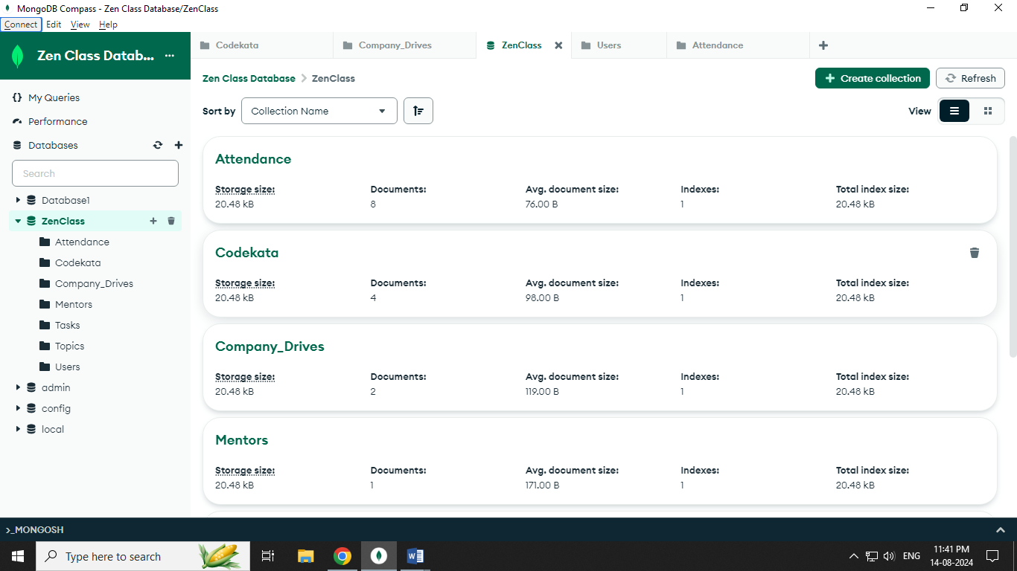

User Collection:

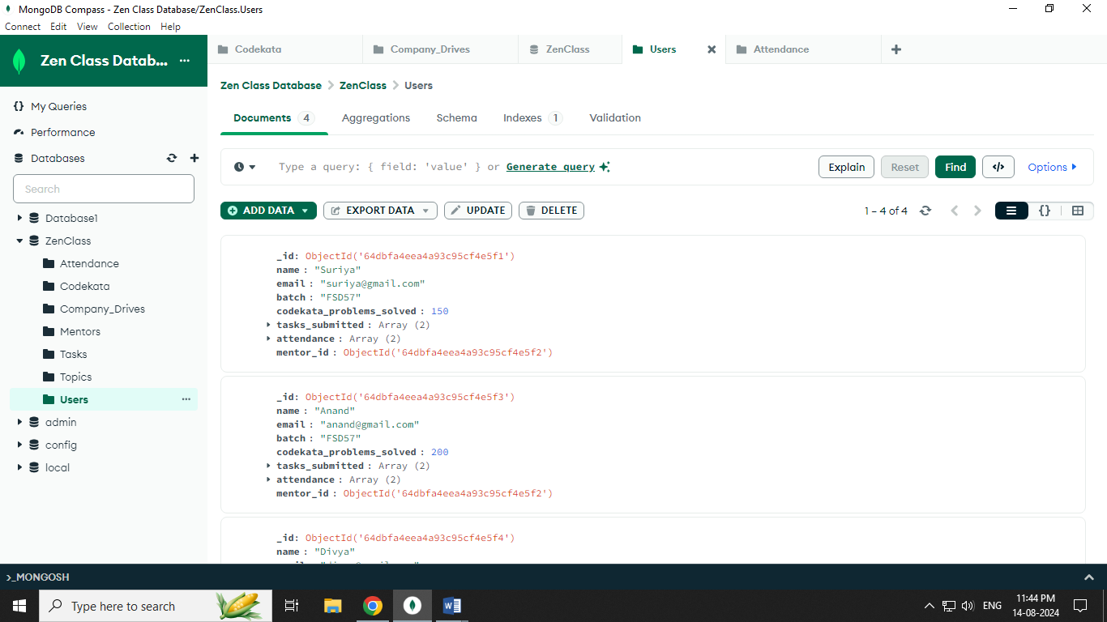

Topics Collection:

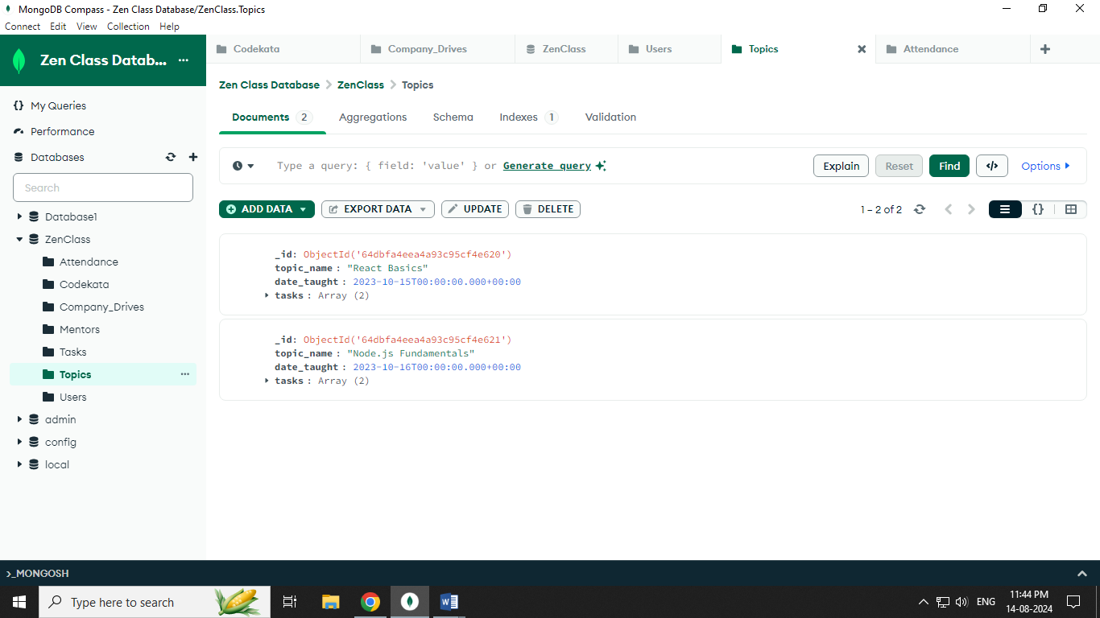

Tasks Collections:

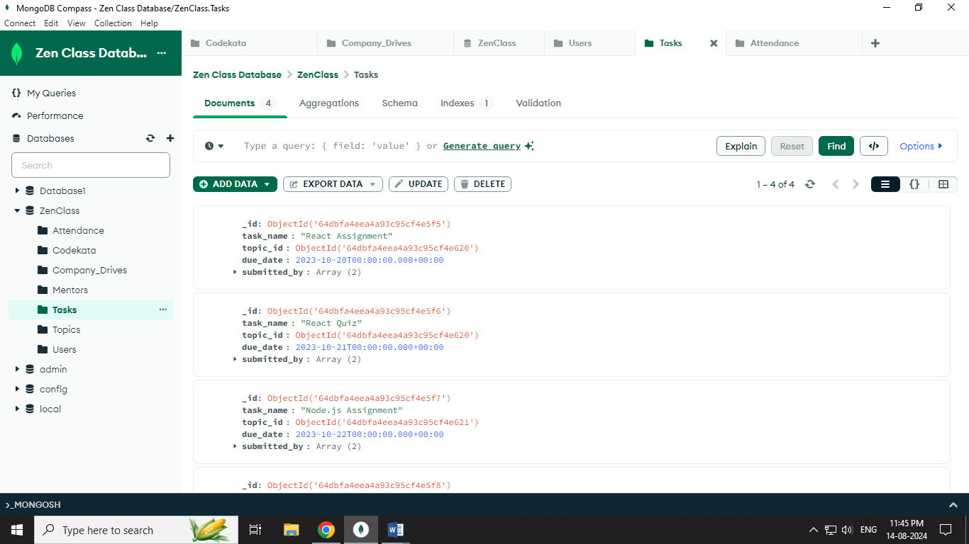

Mentors Collections:

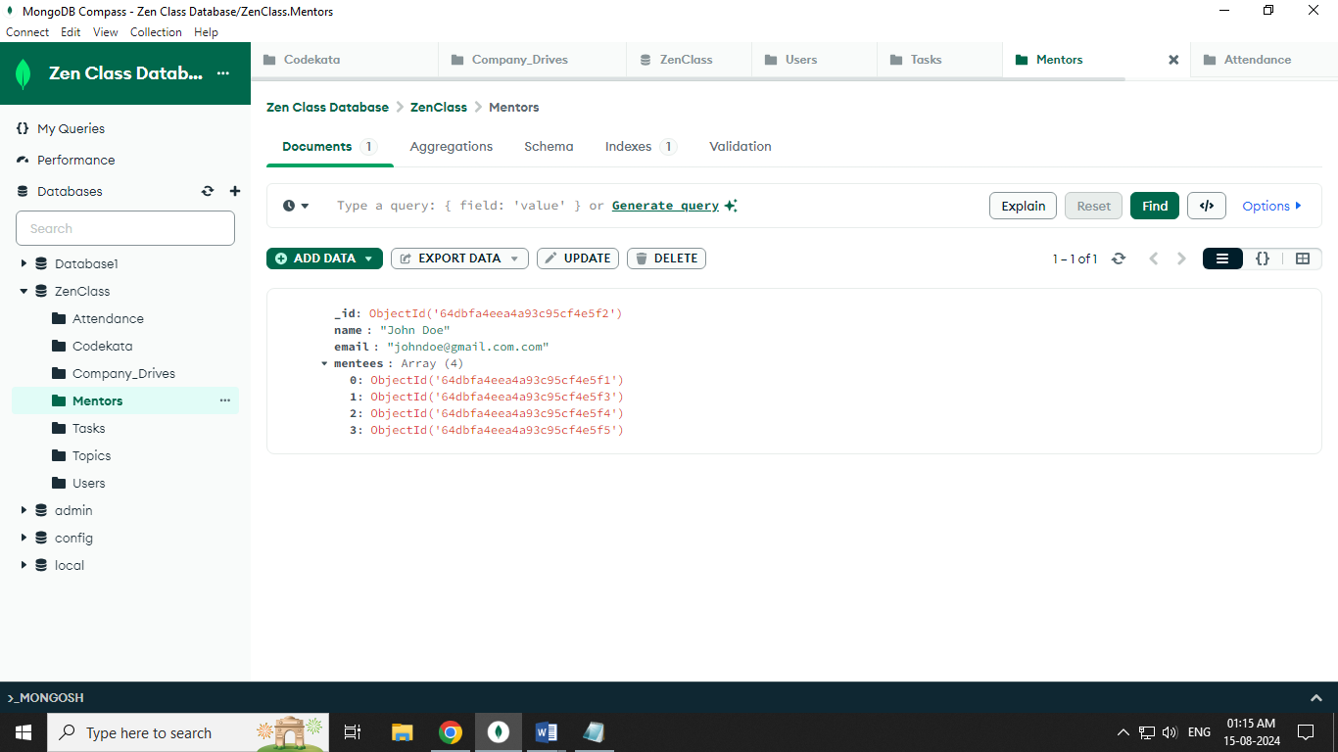

Company Drives Collections:

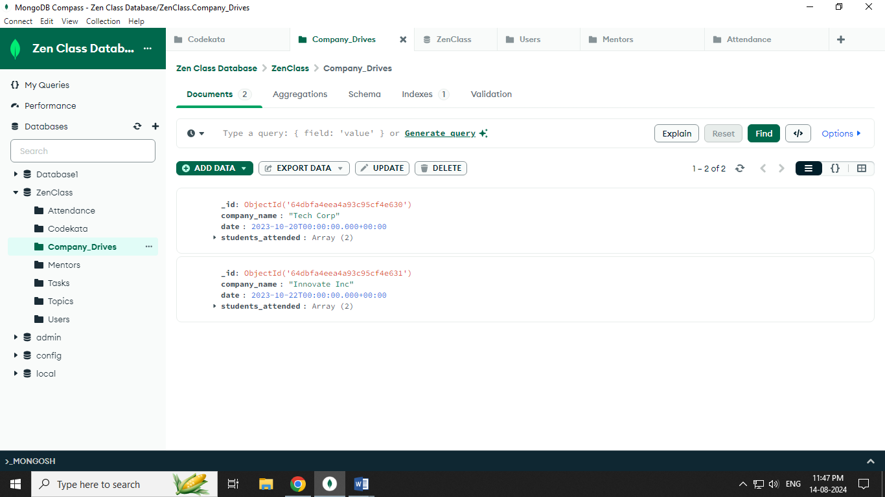

Codekata Collections:

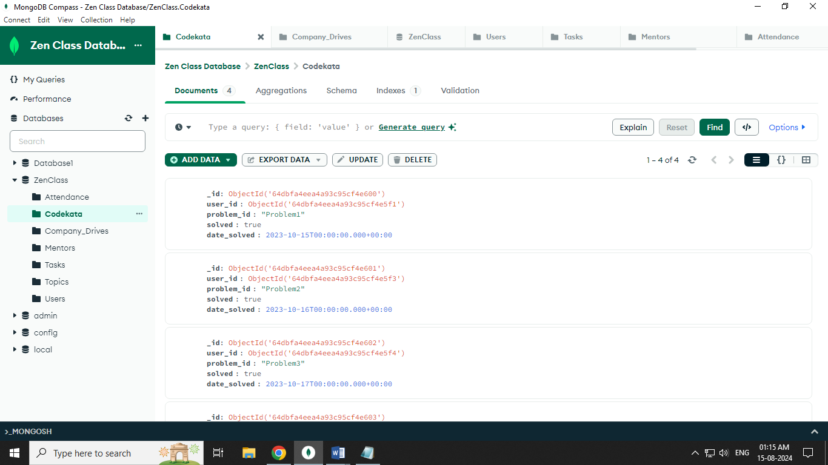

Attendance Collections:

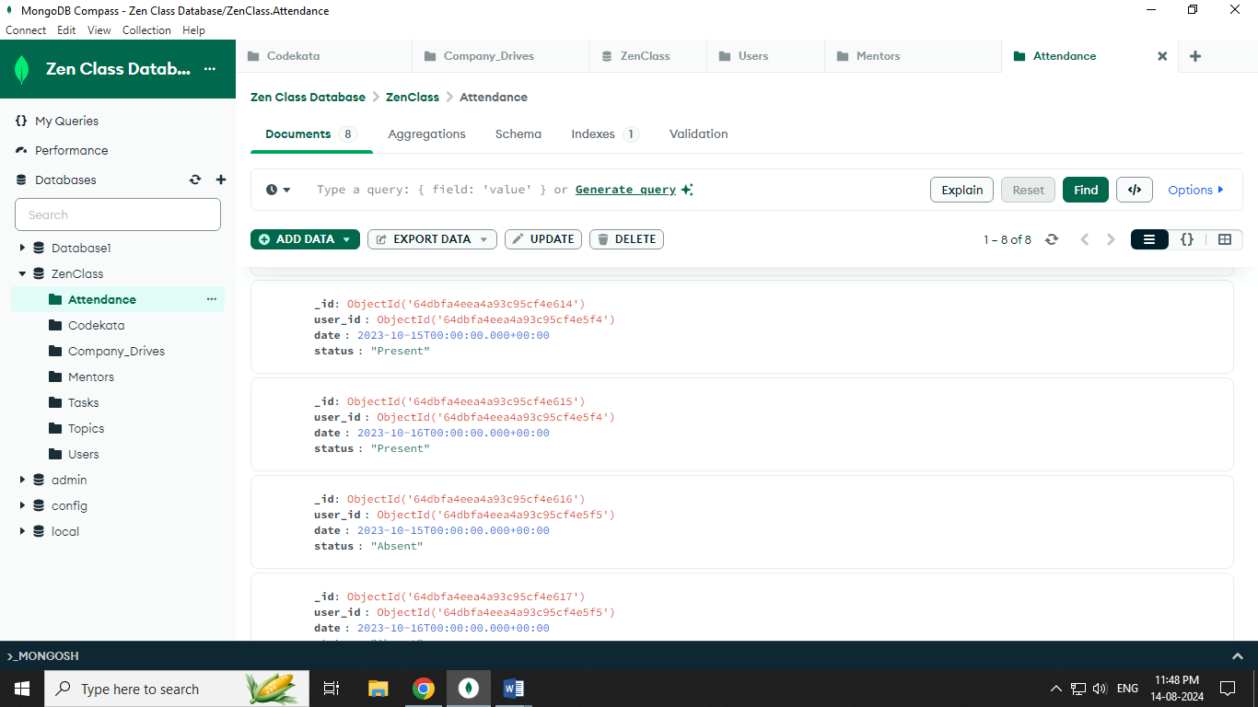

1.Find all the topics and tasks which are thought in the month of October:

**Query:** db.Topics.aggregate([{

$match: {date_taught: { $gte: ISODate("2023-10-01T00:00:00Z"),

$lt: ISODate("2023-11-01T00:00:00Z") } }

},

{$lookup: {from: "tasks", localField: "_id", foreignField: "topic_id", as: "tasks"} },

{$project: {topic_name: 1, date_taught: 1, tasks: {_id: 1, task_name: 1, due_date: 1 } }

}])

2.Find all the company drives which appeared between 15 Oct 2020 and 31 Oct 2020:

**Query:** db.company_drives.find({ date: {

$gte: ISODate("2020-10-15T00:00:00Z"),

$lt: ISODate("2020-11-01T00:00:00Z") }})

3. Find all the company drives and students who appeared for the placement:

**Query:** db.Company_Drives.aggregate([

{

$lookup: {

from: "users",

localField: "students_attended",

foreignField: "_id",

as: "students"

}}

])

4. Find the number of problems solved by the user in Codekata:

**Query:** db.Users.aggregate([{

$project: { name: 1, codekata_problems_solved: 1 }

}])

5. Find all the mentors who have mentee's count more than 15:

**Query:** db.Mentors.find({

"mentees": { $exists: true, $size: { $gt: 15 } }

})

6. Find the number of users who are absent and task is not submitted  between 15 oct-2020 and 31-oct-2020

**Query:** db.Users.aggregate([

{$match: {

"attendance.date": {

$gte: ISODate("2020-10-15T00:00:00Z"),

$lt: ISODate("2020-11-01T00:00:00Z") },

"attendance.status": "Absent" } },

{$lookup: {

from: "Tasks",

localField: "_id",

foreignField: "submitted_by",

as: "tasks_submitted" } },

{$match: {

"tasks_submitted.due_date": {

$not: {

$gte: ISODate("2020-10-15T00:00:00Z"),

$lt: ISODate("2020-11-01T00:00:00Z")

} } } },

{$group: {

_id: "$_id",

name: { $first: "$name" },

absent_days: { $sum: 1 }

}},

{$count: "total_users"}

])